# Cover page

**Data Warehousing and Business Intelligence**

**IT3021**

**Assignment 2**

**Delivery Center: Food & Goods orders in Brazil**

**2022**

**IT20220860**

**Karawita K.S.A**

Contents

Cover page 1

Step 1: Data source for the assignment 2 3

ER Diagram from SSMS 4

Step 2: SSAS Cube implementation 5

Data Source View Diagram 5

Data CUBE Diagram 6

Step 3: Demonstration of OLAP operations 8

Roll-Up 8

Drill-Down 9

Slice 9

Dice 10

Step 4: SSRS Reports 10

References 10

# Step 1: Data source for the assignment 2

I have used the same data warehouse I implemented and loaded with data in assignment 1 as the data source for the assignment 2

<https://www.kaggle.com/datasets/nosbielcs/brazilian-delivery-center>

The Delivery Center is a platform that integrates retailers and marketplaces, creating a healthy ecosystem for sales of goods and food in Brazilian retail. I currently have a register with more than 14000 records. Thousands of orders and deliveries are processed daily with a network of thousands of merchants and delivery partners spread across all country regions.

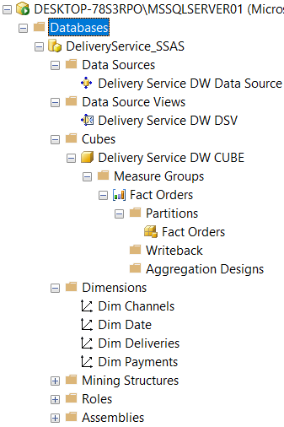

## ER Diagram from SSMS

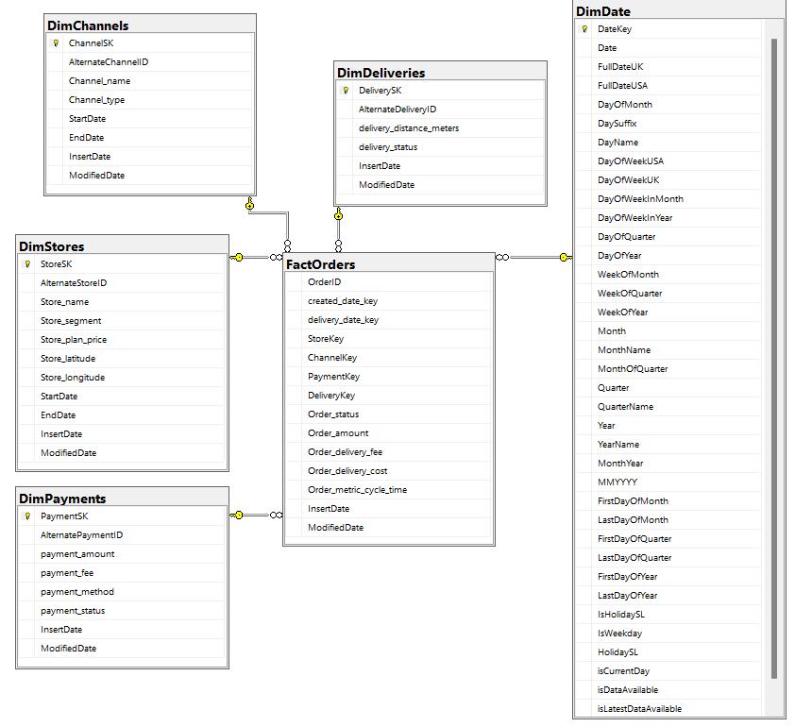

# Step 2: SSAS Cube implementation

## Data Source View Diagram

The data source view created using the data source imported from the DeliveryService_DW data warehouse.

## Data CUBE Diagram

Data CUBE is created using the Data Source View implemented previously.

Deployment and processing the CUBE

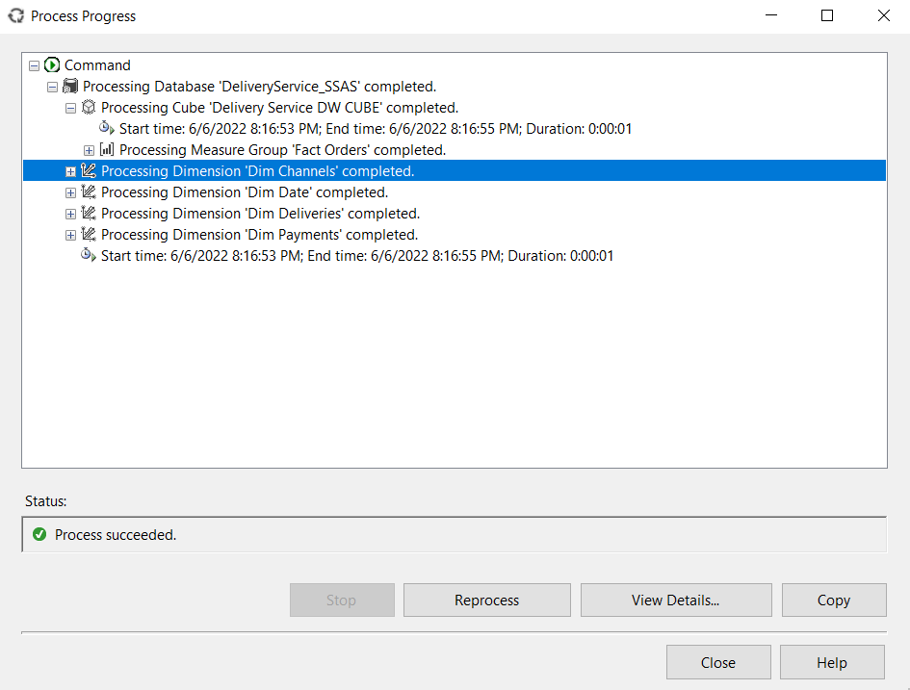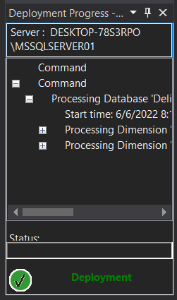

Creating the KPI for the analysis process.

Using this KPI we can filter records with a order delivery cost higher than 10.0000 to further stages of analysis.

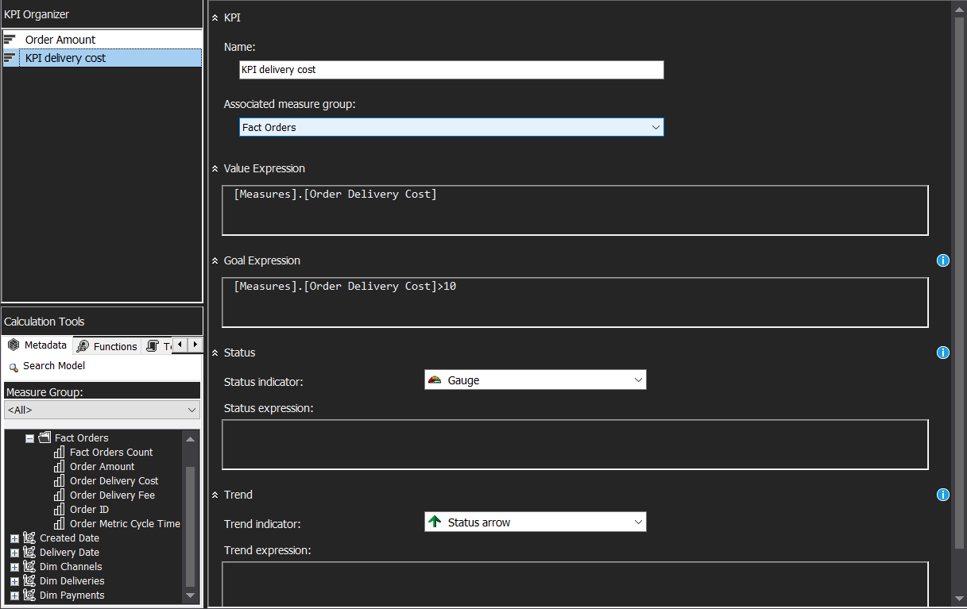

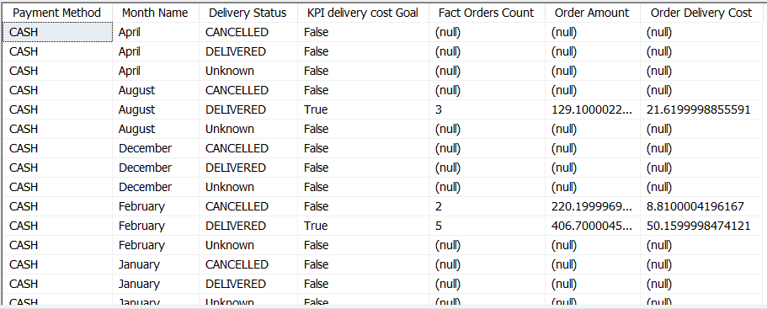

# Step 3: Demonstration of OLAP operations

## Roll-Up

We can obtain the sum of order amounts and the sum of delivery costs of a corresponding payment methods used by customers according to the delivery status of the deliveries.

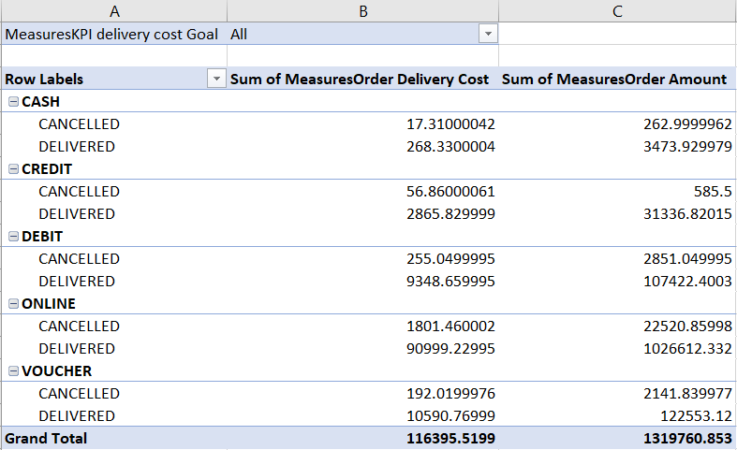

## Drill-Down

## Slice

This gives us the counts of orders and deliveries according to the delivery statuses of corresponding deliveries.

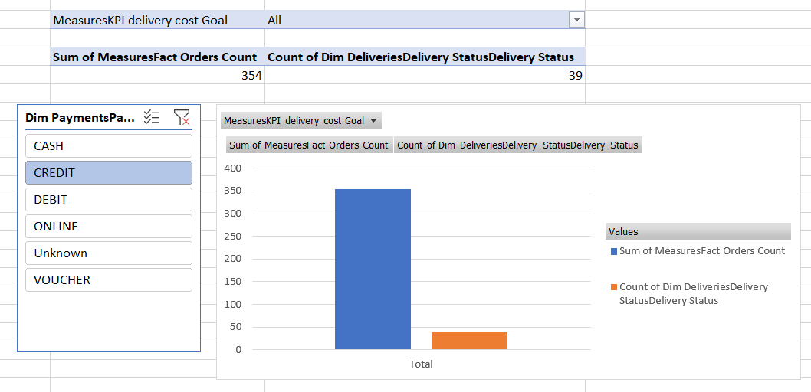

## Dice

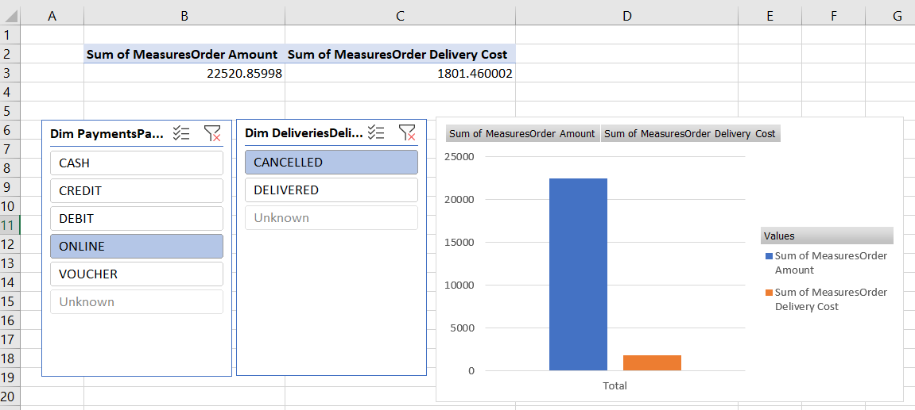

# Step 4: SSRS Reports

# References

<https://docs.microsoft.com/en-us/sql/sql-server/end-of-support/sql-server-end-of-support-overview?view=sql-server-ver16>

<https://www.w3schools.com/sql/>

<https://stackoverflow.com/>

<https://www.sqlservercentral.com/forums/topic/cube-process-failure-is-there-a-way-to-process-dimensions-before-the-cubes-automatically>

Thank You